RECYCLE YOUR ASPHALT SHINGLES IN WARRICK COUNTY!
Join together with Warrick County Solid Waste to help keep asphalt shingles out of our landfills!

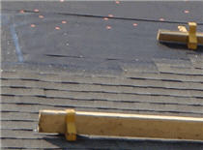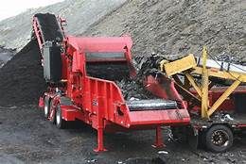
Studies have shown, that asphalt shingles take approximately 300 years to break down in our landfills.

